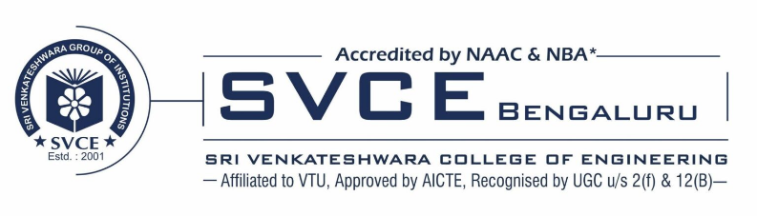
PUBLICATIONS DETAILS
DEPARTMENT OF CIVIL ENGINEERING
- M. S., Latha, Naveen Kumar B. M., Thyagaraj K. J., Praveen G., Ramya N., and M. B. Ananthayya. “An Intelligent System to Analyze Thermal Effect of Stabilized Soil Block”. International Journal of Intelligent Systems and Applications in Engineering 11, no. 9s (July 12, 2023): 661–670.
- Chinmaya M C, Latha M S, Revanasiddappa Madihalli; Naveen Kumar B M, Nahusha S “Seismic analysis of RC building with floating column using nonlinear static analysis”, proceedings of interdisciplinary humanitarian conference for sustainability (IIHC), international, Nov 2022
- Divya K; Revanasiddappa Madihalli; Latha M S; Naveen Kumar B M; Ranjitha H C, “ Study on Influence of Rigid and Semi Rigid Diaphragm System on RC Structure” proceedings of interdisciplinary humanitarian conference for sustainability (IIHC), international, Nov 2022
- Revanasiddappa M, Latha M S, “Data for development of sustainable high-performance concrete and its mix optimization incorporated with fly ash and steel slag – Industrial Waste”, National Conference on documenting Innovation and Creativity in Engineering (DICE 2021), September 2021.
- Chaitra K, Latha M S “Fem Analysis Of Underground Water Storage Tank Subjected To Earthquake Loads In All The Zones”, Journal of Chengdu University of Technology, September 2021, Vol. 26, Issue 9.
- Karthik K, Latha M S, “Structural Behaviour Of Stabilised Soil Reinforced Beam” Journal of Chengdu University of Technology, September 2021, Vol. 26, Issue 9.
- Sharath H Mylarappa, Revanasiddappa Madihalli, Naveen Kumra B M, “Study On Static And Dynamic Response Characteristics Of Hybrid Rc Framed Structure Incorporating Composite Encased Elements” . Journal of Chengdu University of Technology, September 2021, Vol. 26, Issue 9.
- Shaikh Amanisa Nizamoddin, Revanasiddappa Madihalli, Naveen Kumra B M, “Study On Effect Of Diaphram Discontinuity And Optimization Of Structural Response Of Rc Structure With Varing Percentage Of Diaphram Discontinuities”, Journal of Chengdu University of Technology, September 2021, Vol. 26, Issue 9.
- Yashaswini M K, Priyanka S, Naveen Kumar B M, “Dynamic winkler model for non-linear soil structure interaction analysis for different structural systems on tall building” Journal of Chengdu University of Technology, September 2021, Vol. 26, Issue 9.
- Thanuja K M, Naveen Kumar B M, Revanasiddappa Madihalli, Vinutha K, “Using Pushover Analysis For The Assessment Of Dual Structural System”, Journal of Chengdu University of Technology, September 2021, Vol. 26, Issue 9.
- Harish Gowda H B, Revanasiddappa Madihalli, “Comparative Analysis Of High Strength Reinforced Concrete Beam With And Without Basalt Fibre And Alccofine Material Using Etabs Software”, Journal of Chengdu University of Technology, September 2021, Vol. 26, Issue 9.
- Latha M S, Pratibha K, “Analysis And Comparison Of Conventional Slab And Grid Slab For Symmetric And Asymmetric Structures”, Elsevier - Materials Today: Proceedings(Sciencedirect), Proceedings 46 (2021)1860-1869, Mar- 2021
- Thyagaraj K J, Aravindan S, Ahmed Ejaz Fazal, “Utilization of Pond Ash And Stone Dust as Mineral Fillers in Polymer Modified Bituminous Concrete Mix”, International Journal Of Advanced Research In Engineering And Technology (IJARET), Vol. 12, Issue-2, Pp. 785-793, Feb- 2021
- Naveen Kumar B M, Latha M S, Priyanka S, Rudraswamy M P, “Flexural Behaviour and Validation of Reinforced Concrete Beams with Opening Using Foundry Sand”, International Journal of Recent Technology And Engineering (IJRTE), issn:2277-3878, volume-8, issue-6, Jan -2020
- Latha M S, Naveen Kumar B M, Revannasidappa Madihalli, Deepika R, Rudraswamy M P, “Strength Characteristics of High Performance Concrete Using Bagasse Ash and Slag Sand”, International Journal of Emerging Trends in Engineering Research (Ijeter), Issn:2347-3983,Volume-8, No-6, June -2020
- Latha M S, “Model Approach To Optimise Cement, Clay And Coconut Coir In Stabilised Coir Blocks”, International Journal Of Advanced Research In Engineering And Technology (IJARET)” Vol.11, Issue - 12, pp.2100-2105, Dec- 2020

