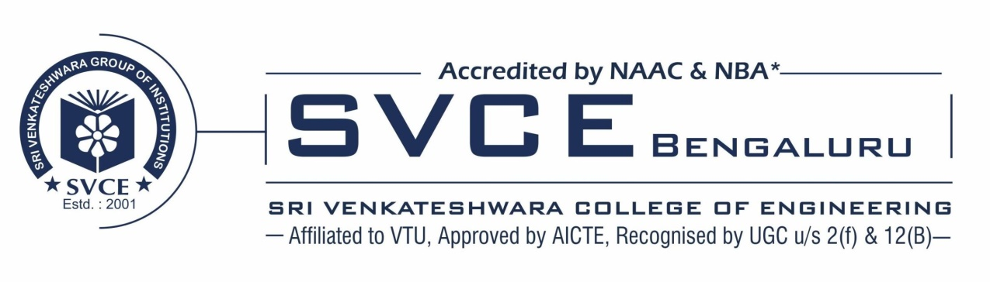
DEPARTMENT OF CIVIL ENGINERRING
RESEARCH PROJECTS
NAME OF THE PROJECT/ ENDOWMENTS, CHAIRS | NAME OF THE PRINCIPAL INVESTIGATOR/ CO-INVESTIGATOR | YEAR OF AWARD | AMOUNT SANCTIONED | DURATION OF THE PROJECT | NAME OF THE FUNDING AGENCY
DEVELOPMENT OF THE SCIENTIFIC BASIS FOR THE CREATION OF EFFECTIVE HIGH MOLECULAR WEIGHT SURFACTANTS THAT IMPROVE THE TECHNOLOGICAL PROPERTIES OF DISPERSE SYSTEMS | DR. LATHA.M. S  PROF. REVANASIDDAPPA M  PROF. NAVEEN KUMAR BM  PROF. PRIYANKA S | 2020 | 13,57,800/ | 3 YEARS | DST, BILATERAL WITH UZBEKISTAN
UTILIZATION OF AI IN TRAFFIC MANAGEMENT TO EASE TRAFFIC CONGESTION | KARTHIK S N SHIVANNA B B ANMOL SHETKAR MANASA K M | 2023 | 4000 /- | 6 MONTHS | KSCST
EFFECTS OF ADDITIVES AND CHARACTERISTICS OF THE BITUMINOUS MIXES | NISCHITHA.N SHAIK SAMEENA AZMY CHALLA ROHINI MEGHANA.K | 2023 | 3500 /- | 6 MONTHS | KSCST
SUPPLY CHAIN MANAGEMENT OF FOOD ITEMS IN COLD STORAGE SYSTEM USING IOT | BHASKARA SREEKARI CHANDULA LIKHITHA SACHIN YAKKELLI RAYAVARAM JAYA SREE | 2023 | 3000 /- | 6 MONTHS | KSCST
PRODUCTION OF BIODIESEL USING WASTE COOKING OIL | KARTHIK K B K NIKHILRAJ ROHITH KAIYAN KUMAR REDDY CHAMALA KOTA UDAY KUMAR REDDY | 2023 | 5000 /- | 6 MONTHS | KSCST
SMART IRRIGATION USING IOT | PRAJWAL S R.  AKSHAY KUMAR KENCHOLE MIR RASIQ BASHIR KARAN ANAND | 2023 | 5000 /- | 6 MONTHS | KSCST
EXPERIMENTAL INVESTIGATION ON SYNERGITIC EFFECT OF MIXED (CARBON/ METAL OXIDE) NANO PARTICLES ON CI ENGINE COMBUSTION | SAMEER AHMED S SYED SAQUIB AHMED SACHIN.A RAJESH B N | 2023 | 7500 /- | 6 MONTHS | KSCST
DEVELOPMENT AND ANALYSIS OF ELECTRIC VECHICLE BATTERY HEATING ISSUE | SRUJAN K S BHARATH REDDY SU VENUGOPAL G PAVANKUMAR S | 2023 | 7000 /- | 6 MONTHS | KSCST
TEMPERATURE MONITORING IN FOOD/PHARMA APPLICATION | VIKHYATH STHAVARMATH PRAVEEN H N TEJAS S PRUTHVIK K R | 2023 | 7000 /- | 6 MONTHS | KSCST

