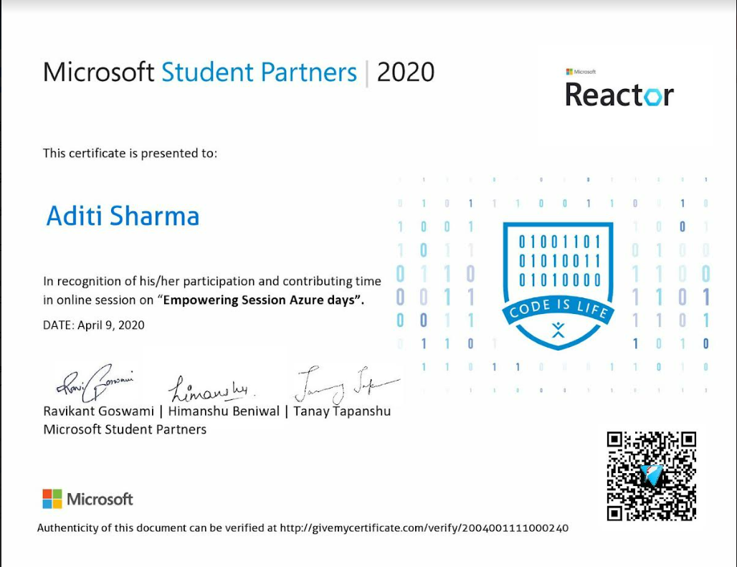

Aditi Sharma
4th sem
Cse- AI
From Microsoft student partner Aditi Sharma received certificate for session conducted on Empowering session Azure days on 9th April 2020
In the recognization of her participation and contributing time in online session on “empowering session Azure days”.

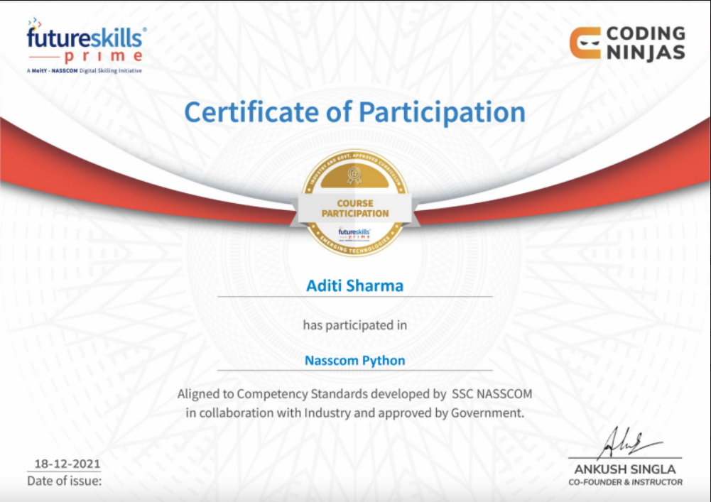
Aditi Sharma
4th sem
Cse- AI
Certificate from NASSCOM Python on 19/12/21
Coding Ninjas conducted Nasscom python Aditi sharma participated which was aligned to competency standards developed by ssc NASSCOM in collaboration with industry and approved by government

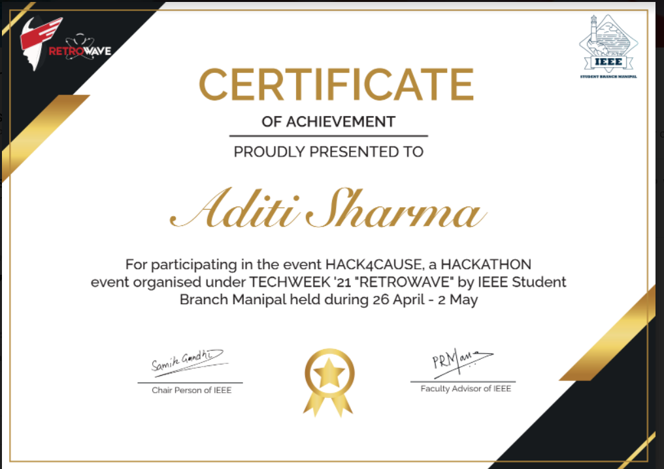
Aditi Sharma
4th sem
Cse- AI
Won Engineer Hackathon’22 - Devfolio
Participated in event Hackathon event organized under TECHWEEK21 “RETROWAVE” From 26 April 2022 – 2 May 2022.
Aditi sharma participated in the event Hack4cause a hackathon event organized under TECHWEEK “21 “RETROWAVE” By IEEE student branch Manipal .

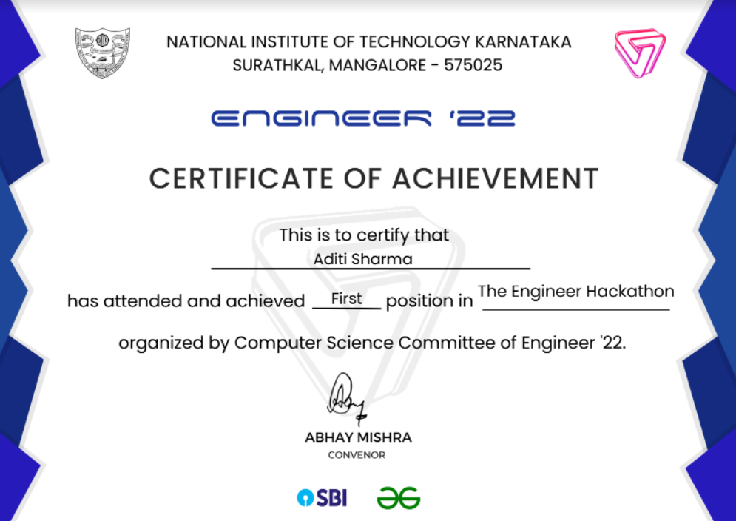

Aditi Sharma
4th sem
Cse- AI
Won Engineer Hackathon’22 – Devfolio
Aditi Sharma got First Price in Engineer Hackathon 22.
National Institute of technology Karnataka conducted engineer hackathon organized by computer science committee of engineer 22 .

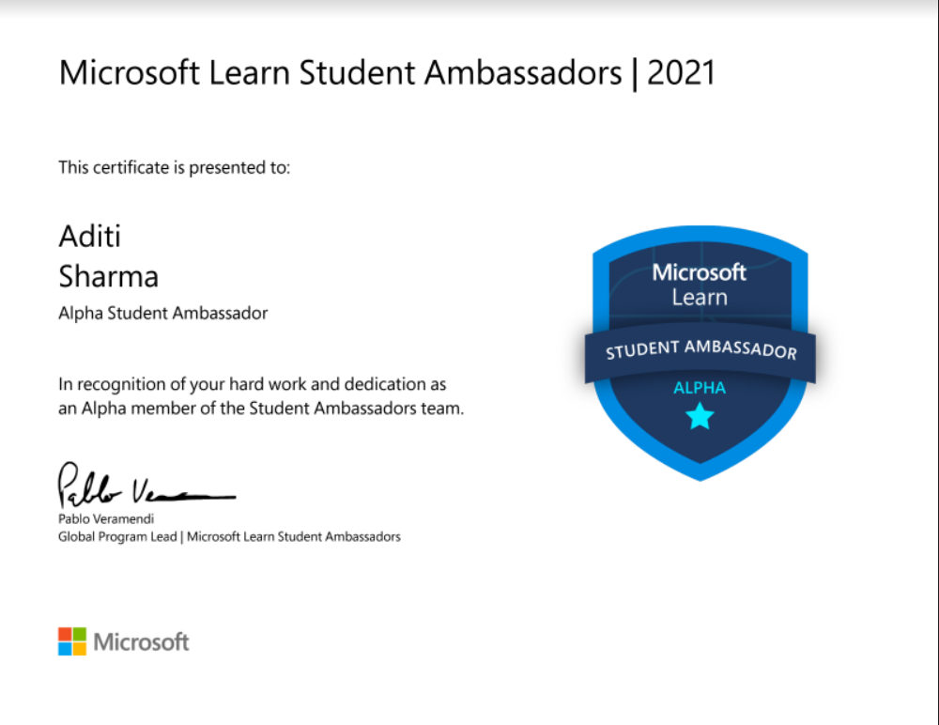

Aditi Sharma
4th sem
Cse- AI
Aditi Sharma is a student Alpha Ambassador for Microsoft from 2021 to present
In the recognization of hardwork and dedication as an alpha member of the student ambassador team.
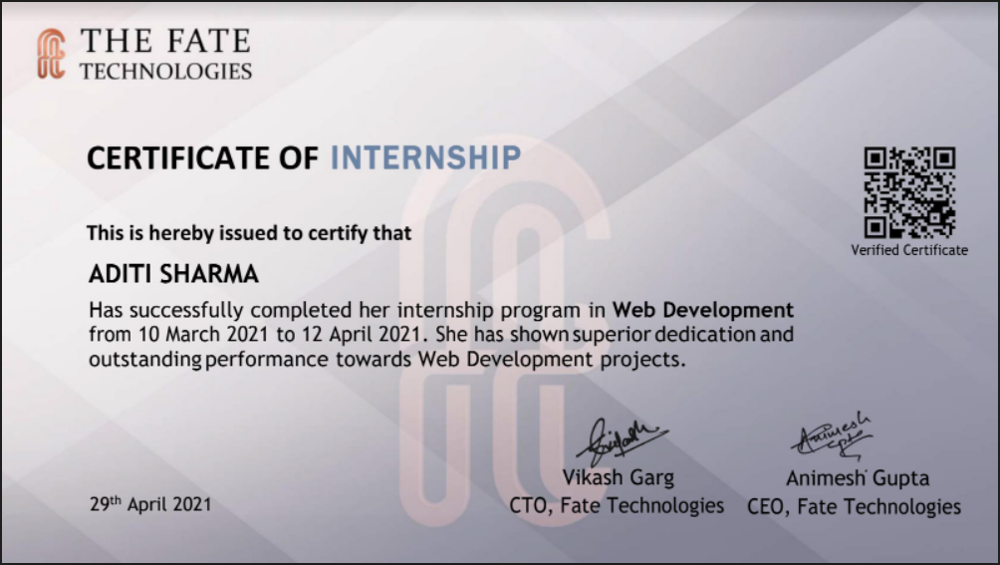

Aditi Sharma
4th sem
Cse- AI
Certificate of 1 month internship in Web development from 10 march 2021 t0 12 april 2021
Aditi sharma successfully completed her internship program in web development. She has shown superior dedication and outstanding performance towards web development projects.

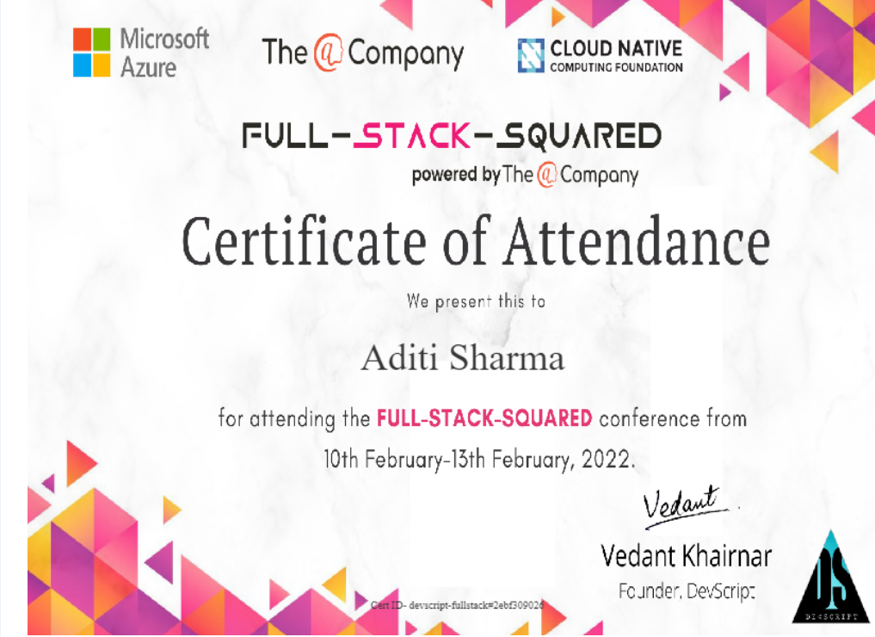

Aditi Sharma
4th sem
Cse- AI
Aditi Sharma attended Full stack squared from cloud native attended from 10th February to 13th February 2022

Full stack squared conference was conducted by Microsoft Azure on 13th February 2022 .

